**E-PROJECT DEVELOPMENT TEAM**

* **PROJECT TITLE**

***ONLINE MOBILE RECHARGE***

* **TEAM MEMBERS :**
* Rameen Khushi
* Abdul Salam
* Daniyal Rashid
* Abdul Rehman
* **PROFESSOR NAME**
* Miss Sahia Jamal
* **BATCH CODE**
* PR2-202310B+09B
* **SEMESTER**
* HDSE1

*CERTIFICATE OF COMPLETION*

* This is to certify that Rameen, Abdul Salam, Daniyal, & Abdul Rehman have successfully completed their ACCP 3rd Semester (HDSE1) E-Project.

## Submitted to : Aptech Computer Education

*On*

21-April-2025

ACKNOWLEDGMENT

We would like to take this opportunity to express our heartfelt gratitude to all those who supported and guided us throughout the successful completion of this project.

First and foremost, we are deeply thankful to our respected instructor **Miss Sahia Jamal** for her valuable guidance, continuous encouragement, and constructive feedback throughout the project development phase. Her insights and support have been instrumental in shaping the direction of our work.

We would also like to acknowledge the efforts of the **E-Project Team at Aptech Head Office** for providing us with the platform and resources necessary to carry out this project efficiently.

Lastly, we extend our appreciation to our friends, classmates, and family members who have offered their constant moral support and motivation during the entire journey. Their encouragement kept us focused and driven.

This project has been a great learning experience and a stepping stone in our professional journey as aspiring IT professionals.

ABRIDGEMENT

This project has been a significant learning experience for our team. Throughout its development, we encountered several technical and logical challenges that tested our understanding of the concepts we have studied so far. Each obstacle provided an opportunity to enhance our problem-solving skills, debug effectively, and explore new tools and techniques relevant to modern web application development.

Working on the **Online Mobile Recharge System** not only improved our knowledge of ASP.NET Core, databases, and system design, but also helped us strengthen our teamwork, planning, and time management skills.

Though we faced difficulties along the way, our consistent efforts and collaboration led us to successfully complete the project. This journey has been an enriching and memorable part of our academic experience.

PROBLEM STATEMENT

In today’s fast-paced digital era, where convenience and efficiency are top priorities, the traditional method of recharging mobile phones by visiting retail stores is becoming increasingly outdated. The existing system requires users to physically go to a recharge outlet, provide their number and recharge amount to the retailer, and wait for the recharge to be processed. This process is time-consuming, prone to human errors, lacks transparency, and is not feasible during urgent situations or odd hours.

Furthermore, maintaining manual records of recharges by retailers increases the chances of data loss, duplication, or mismanagement. There is also limited accessibility for users living in remote or rural areas where recharge shops might not be readily available.

To address these issues, the need arises for a centralized **Online Mobile Recharge System** that automates and simplifies the entire recharge process. This system aims to provide users with the ability to recharge their prepaid mobile phones anytime, from anywhere, using an internet-enabled device. It also ensures secure transactions, maintains a complete recharge history, and provides real-time updates to users regarding their transaction status.

The proposed system will have two main user roles — **Admin** and **User**. Admins can manage recharge plans (add, update, delete), while users can register, login, and recharge their mobile with the available plans. The system will be built using ASP.NET Core and SQL Server, ensuring scalability, speed, and security.

By implementing this system, we aim to eliminate the dependency on physical recharge points, enhance user experience, reduce manual errors, and promote digital transformation in the mobile recharge domain.

Functional Requirement Specification :

The **Online Mobile Recharge System** will be developed as a user-friendly, web-based application designed to offer smooth, secure, and convenient mobile recharge services to customers across various mobile network operators. The portal will follow a structured layout of pages and modules, each designed to facilitate specific user activities such as user registration, mobile recharge, plan browsing, and transaction history viewing. The platform will also provide administrative functionality for managing recharge plans and monitoring user activities.

The system will be developed using **ASP.NET Core** as the backend technology, with a responsive and interactive frontend created using HTML5, CSS3, Bootstrap, and JavaScript. SQL Server will serve as the database engine for managing all records efficiently and securely.

**Key Functional Requirements:**

**1. Visually Engaging and Modern UI:**

* The web application will feature a visually appealing and consistent color scheme.
* Clean fonts, responsive components, and subtle animations will be used to enhance the user interface.
* User interaction points will be clearly visible, providing a seamless experience.

**2. Fully Responsive Layout:**

* The application will be fully responsive, ensuring compatibility across all modern devices — desktops, tablets, and smartphones.
* The layout and components will auto-adjust to fit various screen sizes and resolutions.

**3. Core Functional Sections:**

The platform will be divided into well-structured modules to handle user and admin tasks:

* **Recharge Plans:** Displays all available recharge options based on operator and validity.
* **Recharge History:** Enables users to view their previously made recharges along with timestamps and statuses.
* **Mobile Operators List:** Categorized list of supported telecom providers (e.g., Jazz, Zong, Ufone, Telenor, etc.).
* **Admin Dashboard:** A secure admin panel for managing recharge plans, user data, and reports.
* **Help & Support:** Section for users to ask questions and access basic troubleshooting info.

**4. Informational Pages:**

* **About Us:** Includes an overview of the system, the development team, and contact info.
* **Contact Us:** Provides a simple contact form for user queries.
* **Terms & Conditions / Disclaimer:** Legal usage policy and important notices regarding service terms.

**5. User Registration & Account Management:**

* Users will be able to register by providing their personal information such as name, mobile number, email, and password.
* Once logged in, users can view and update their profile, recharge balance, and transaction history.

**6. Recharge Process Simulation:**

* Users will select an operator, choose a recharge plan, enter mobile number, and confirm recharge.
* Payment can be simulated (in academic version) to showcase the transaction logic.
* On successful recharge, a confirmation message will be displayed and stored in history.

**7. Smooth & Intuitive Navigation:**

* Navigation bar with clear labels for each major section.
* Breadcrumbs and page titles will assist in user orientation within the app.
* Footer links for quick access to site map, terms, and policies.

**8. User Feedback & Engagement:**

* Option for users to rate their experience or leave reviews.
* Admins will be able to view user feedback and take necessary actions for improvements.

**9. Admin-Specific Functionalities:**

* Admin can log in securely using a separate login page.
* Admin dashboard will allow management of:
  + Recharge plans (add/update/delete).
  + View all user data and recharge history.
  + Generate summary reports for internal use.

**10. Extra Links & Utilities:**

* **Site Map:** For quick overview and accessibility.
* **FAQs:** Addressing common issues and how-to.
* **Forgot Password Module:** Helps users recover login credentials via email/mobile OTP simulation.

By implementing the above functional requirements, the **Online Mobile Recharge System** will provide a smooth, secure, and feature-rich user experience. The system will ensure 24/7 accessibility, real-time updates, historical tracking, and administrative control — making it a comprehensive platform for online prepaid mobile recharge.

**Hardware/ Software Requirements**

* A minimum computer system that will help you access all the tools in the
* courses is a Pentium 166 or better
* 128 Megabytes of RAM or better
* Software
* Visual Studio .Net / ASP
* IIS server
* .Net Framework
* Java Virtual Machine/ J2EE server
* Notepad/Java editor
* j2sdk1.4.1_02 (or later).
* EJB Dev Kit
* Java enabled web server
* JSP / Servlets Dev. Kit

# Architecture and Design of the System

HTML

**CSS**

**JAVASCRIPT**

**Server**

**Liberty Electronics**

**SQL**

**ASP.NET**

# ERD DIAGRAM :

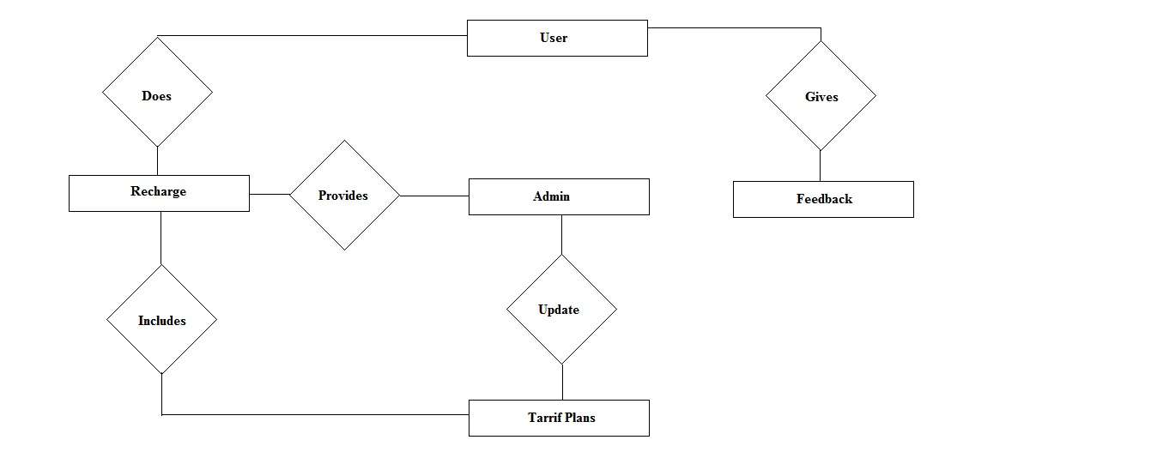

DEVELOPERS GUIDE

In this project, I focused on backend development using technologies such as HTML, CSS, Bootstrap, and JavaScript , ASP.NET which provided a strong foundation for building a dynamic web application. This combination allowed for a seamless integration of front-end and back-end functionalities.

The backend architecture is designed around well-defined classes and IDs, promoting a logical and readable coding structure. This organization makes it easier to understand the code and implement changes when necessary.

By leveraging Bootstrap, we ensured the website remains responsive and visually appealing across various devices. The backend processes facilitate efficient data handling, user authentication, and seamless interactions, enhancing the overall user experience.

This comprehensive approach not only showcases our creativity but also establishes a robust framework for ongoing development and future enhancements.

SITE map

Conceptual Model



USER GUIDE

**NAVIGATION BAR**

The navigation bar is an essential part of the website that allows users to explore all the major sections of the Online Mobile Recharge System. It is placed at the top of every page for easy and quick access. The menu includes options like **Home**, **Online Recharge**, **Post Bill Payment**, **Feedback**, **Site Map**, **About Us**, **Contact Us**, and **Customer Care**. Each button redirects the user to a specific section with relevant functionality. For example, Online Recharge lets users recharge prepaid numbers, while Post Bill Payment supports postpaid users. The design is clean, user-friendly, and responsive, making it accessible on desktop and mobile devices. This helps in smooth navigation and enhances the overall user experience.



**HOME**

Home page is a main page of this application or could be termed as the introductory page containing some of our information and navigation bar at the top working as a gateway to other pages of the site.

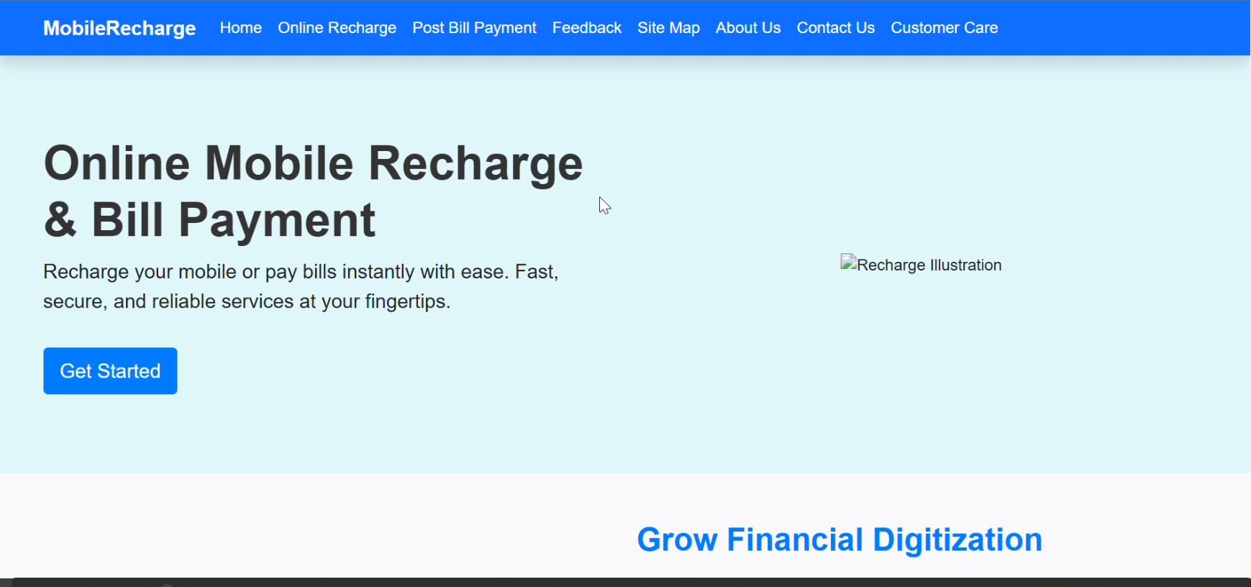

**EDIT PROFILE :**

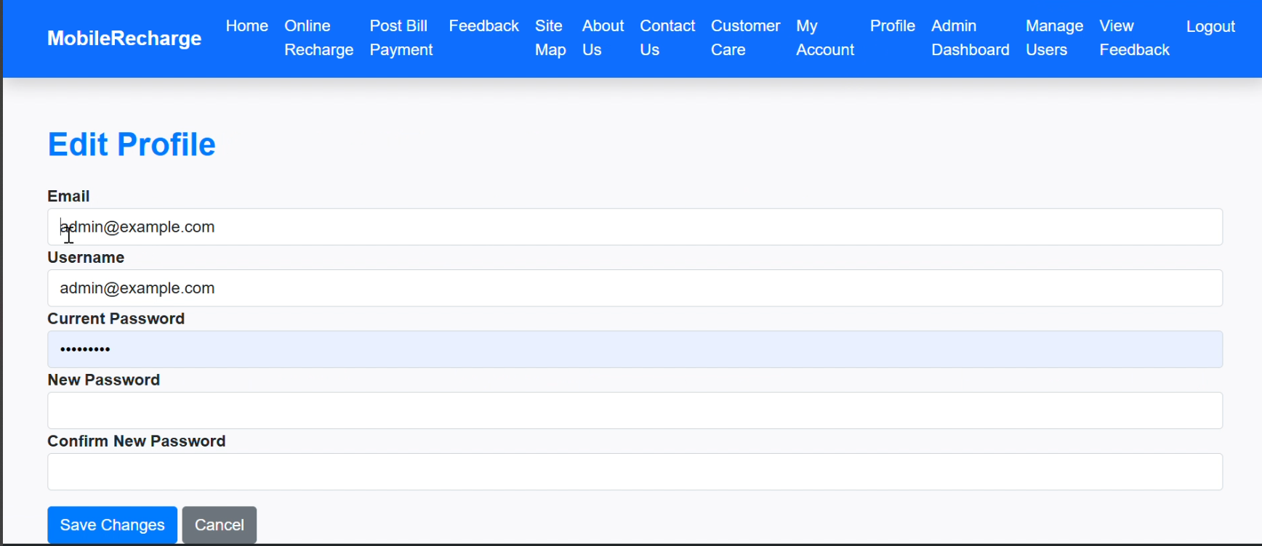

**Customer Care:**

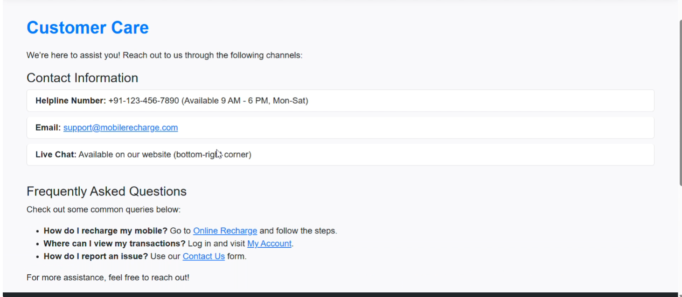

* Post-paid Bill Payment :

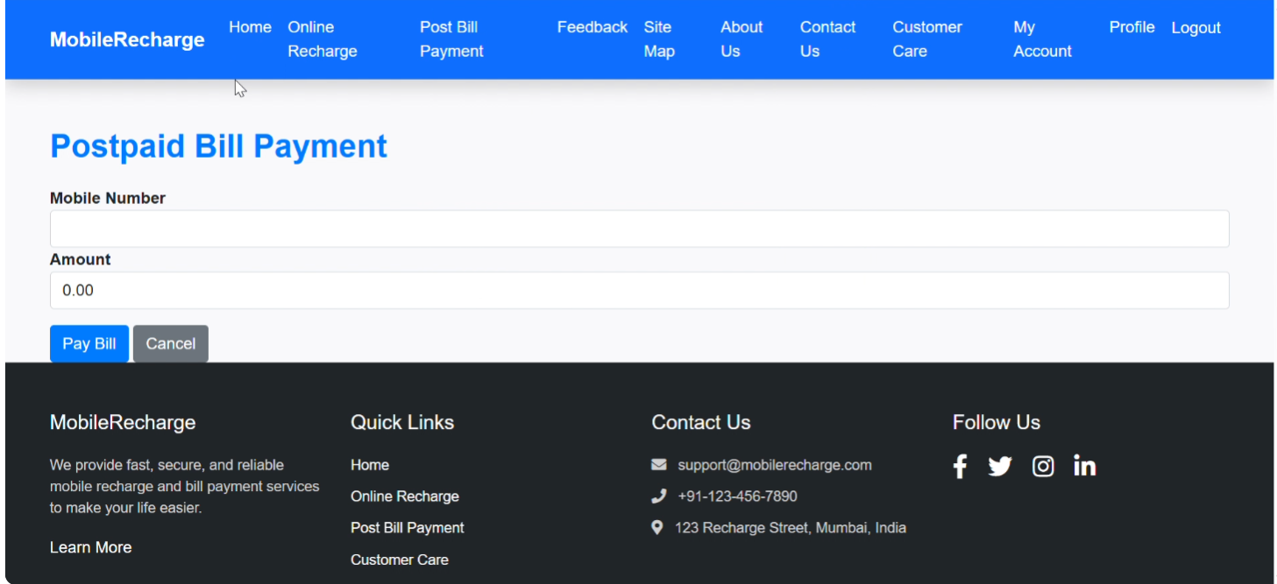

**Site Map :**

In this page, we add our email &amp; phone no. and customer can also send their message easily.

Customer can connect with our social media pages such as, Facebook, Instagram & Twitter.

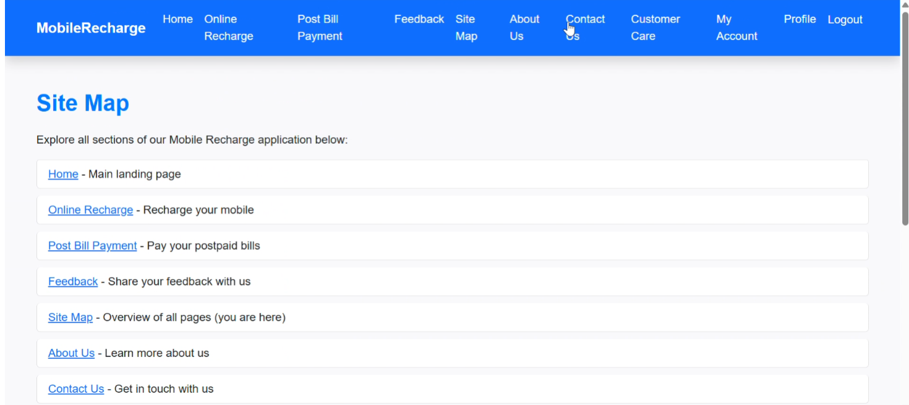

**About US:**

We link this book now button to a booking form. For starting your journey with us you just have to fill this form book your favorite yacht, add some exciting travel to your life and start creating some new memories with your loved ones….

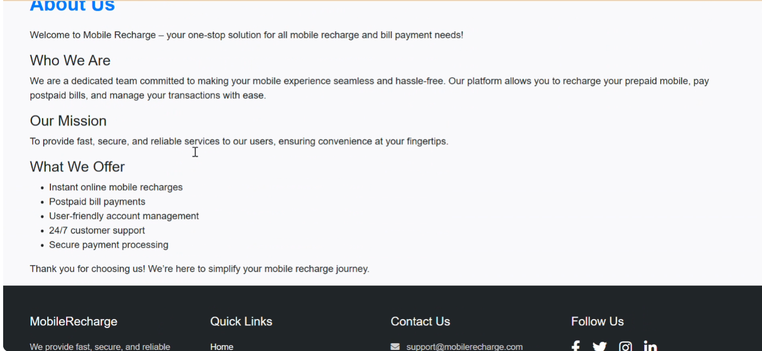

User FeedBack :

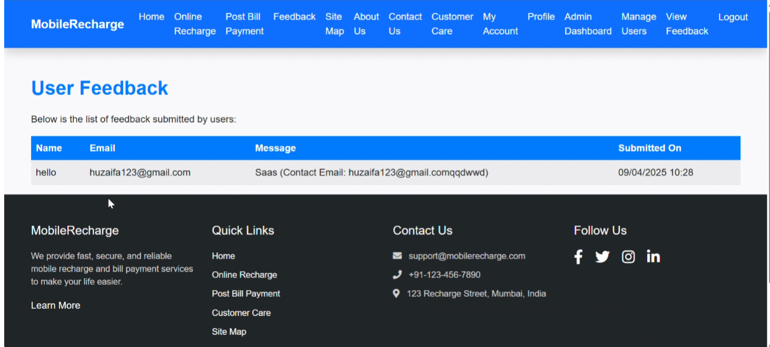

Submit FeedBack :

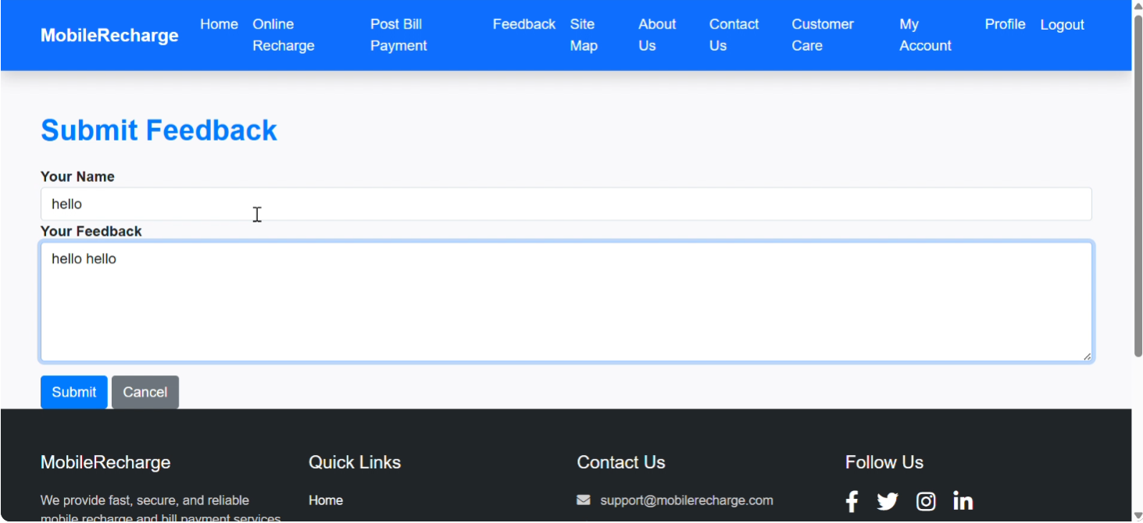

My Transactions:

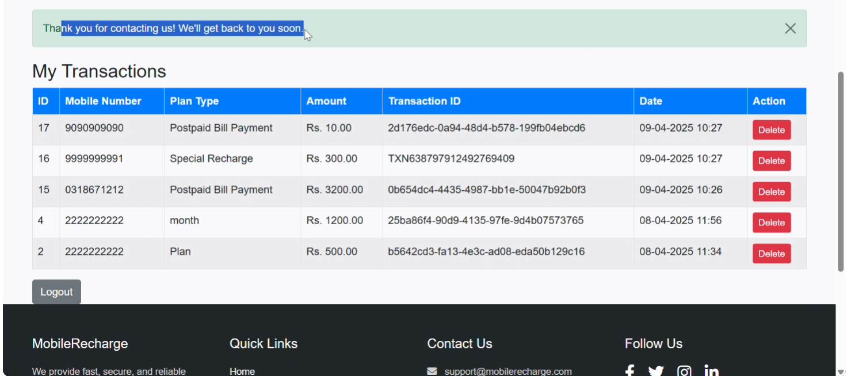

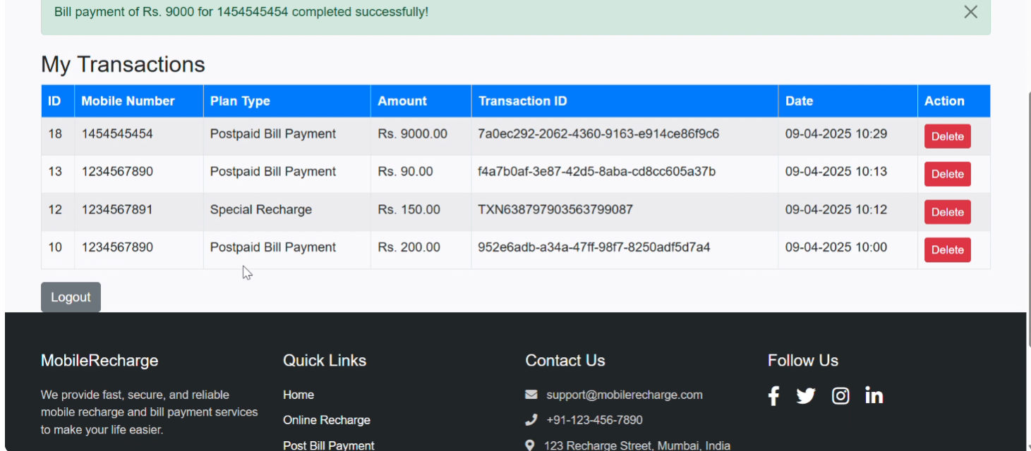

Login:

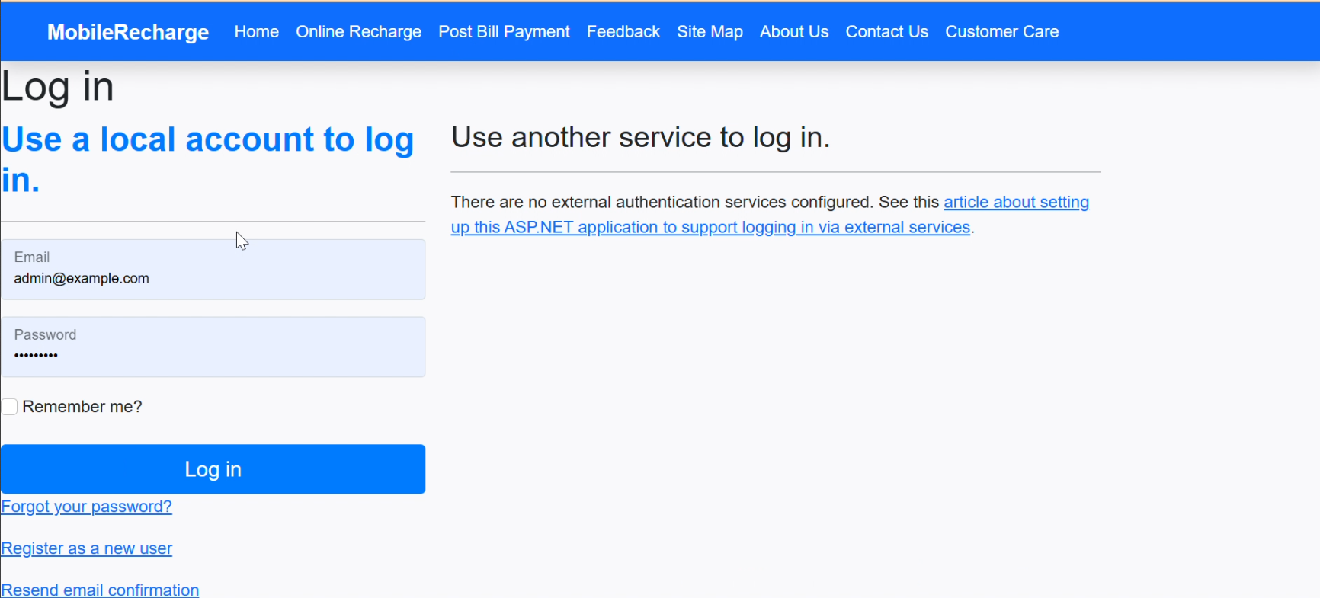

Admin Dashboard:

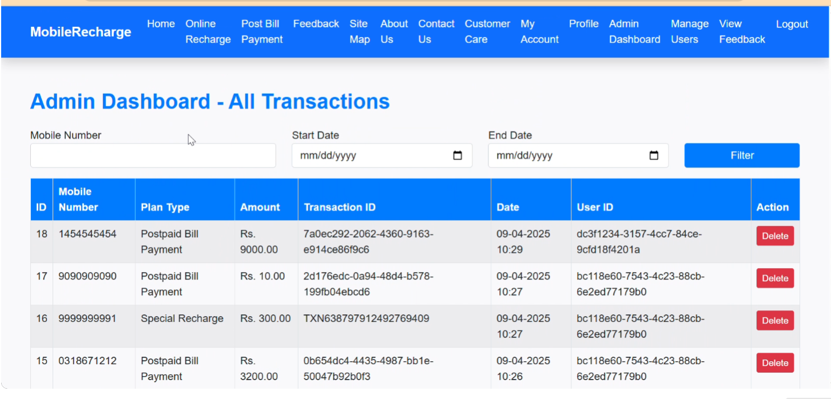

Project Coding :

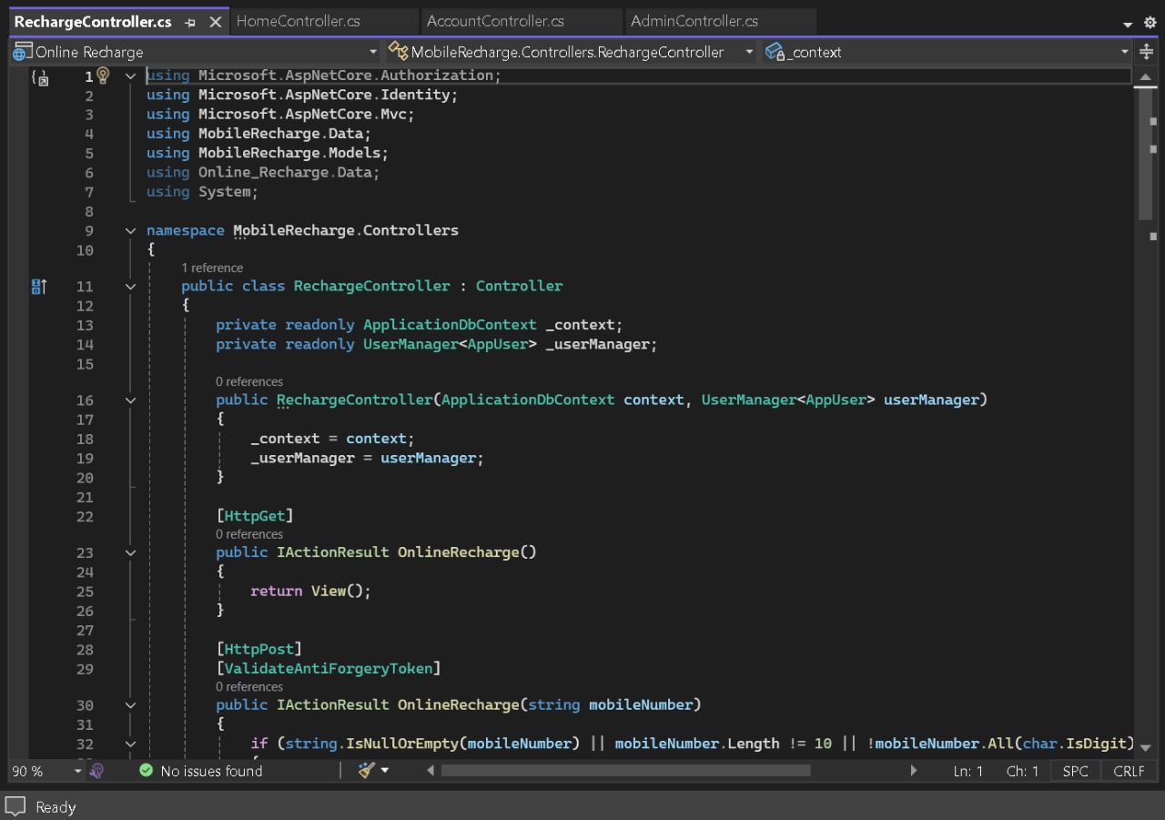

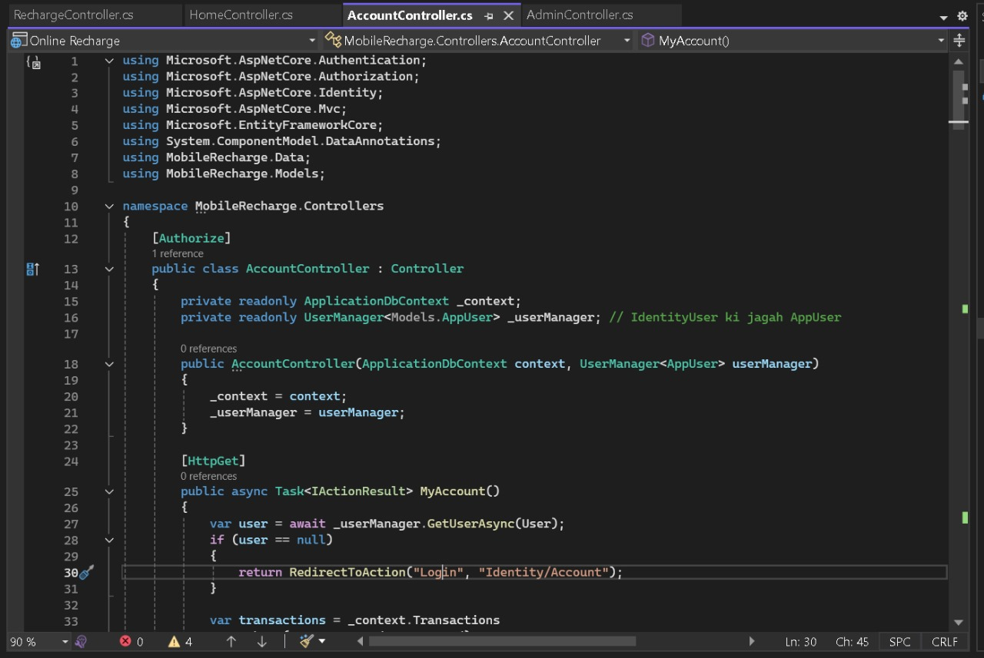

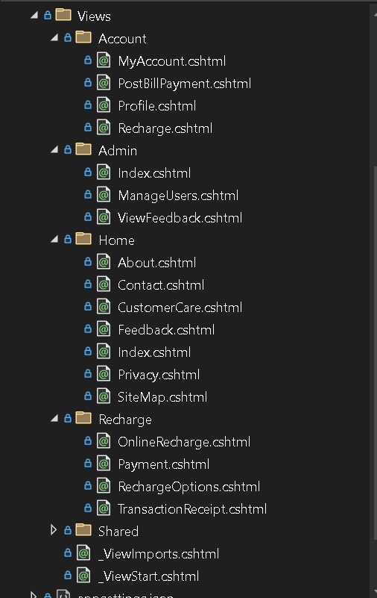

Postpaid Bill payment :

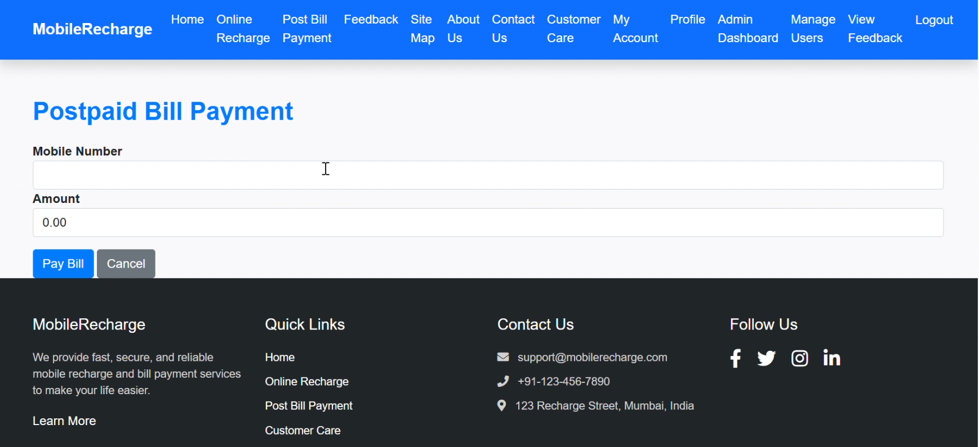

My Account:

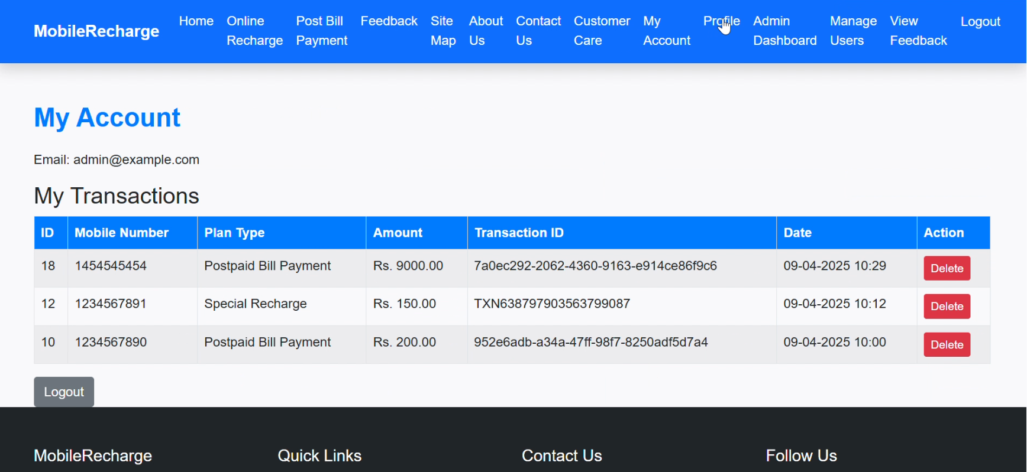

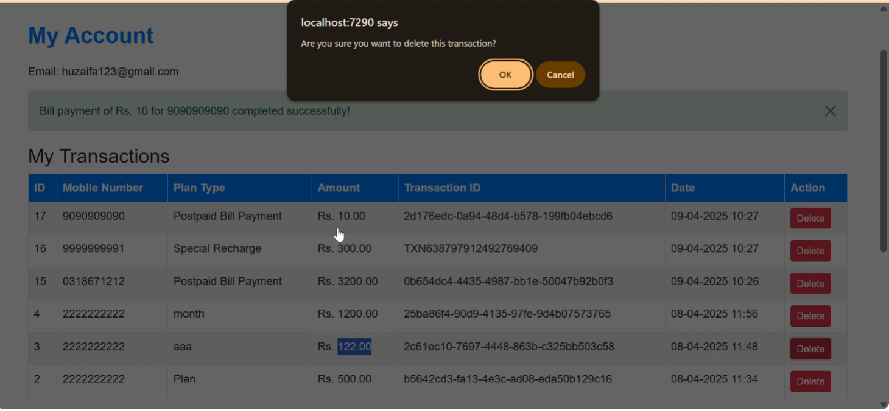

Transaction Successfully:

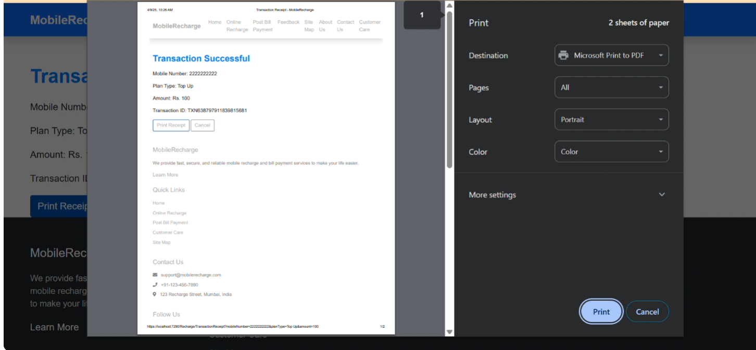

Print:

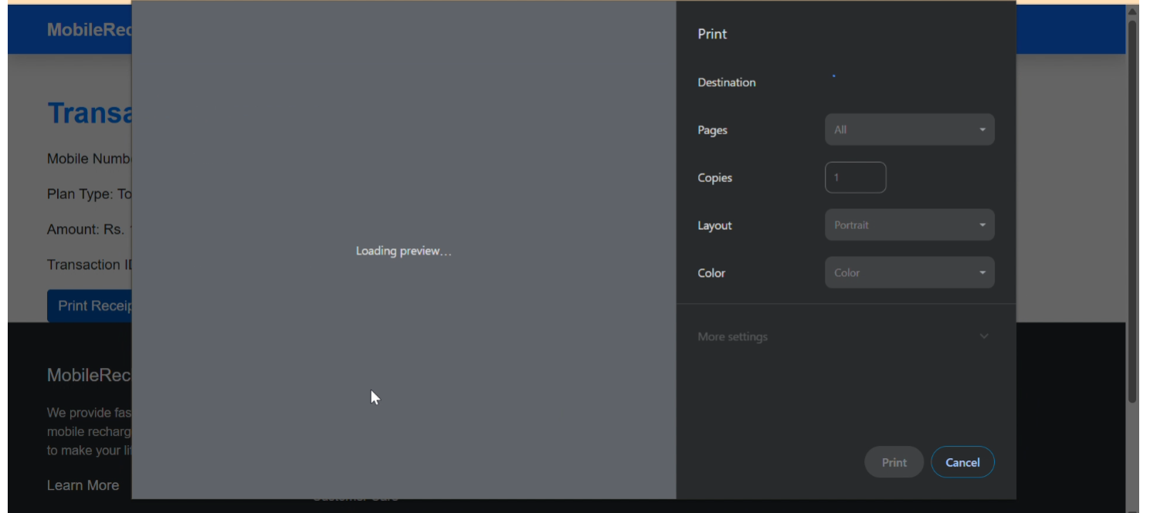

Database:

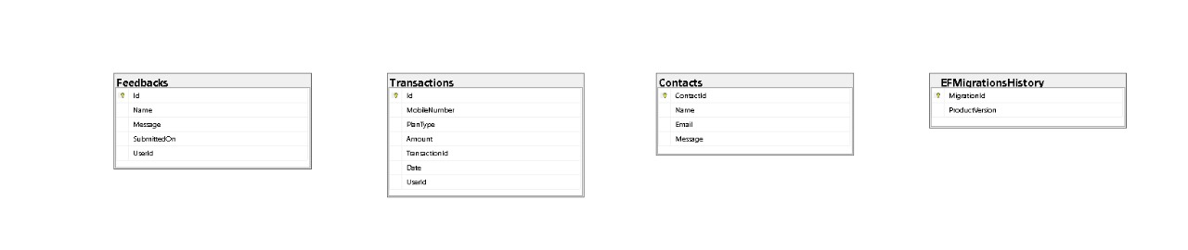

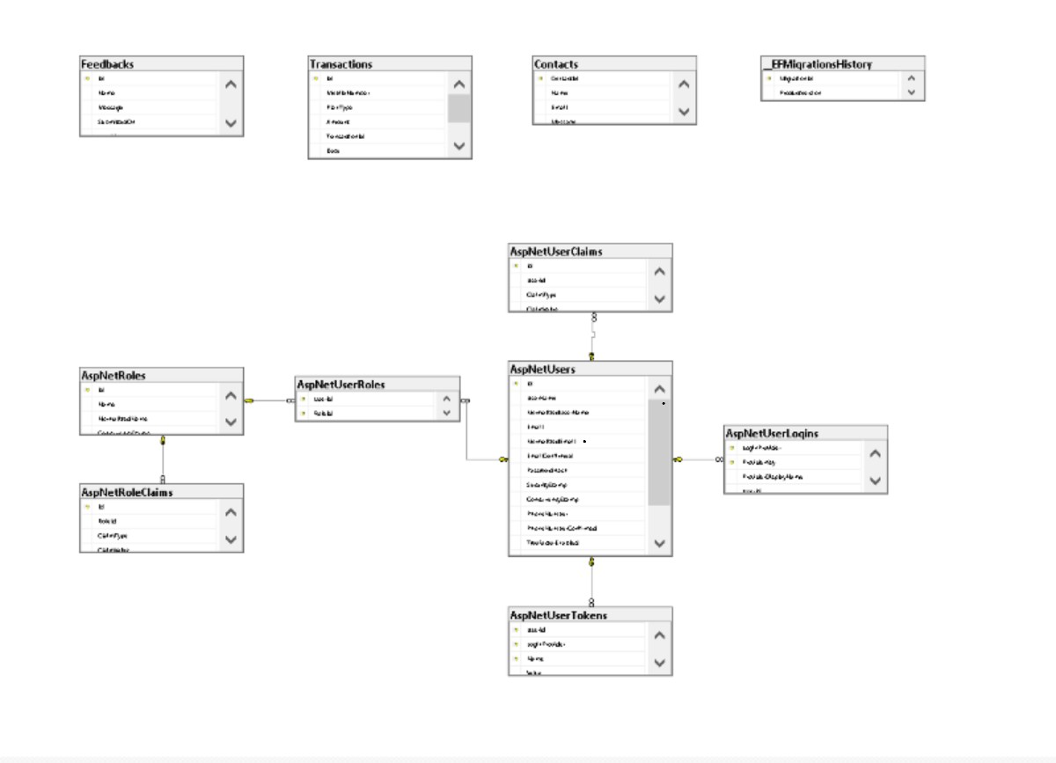

Payment For Top-up:

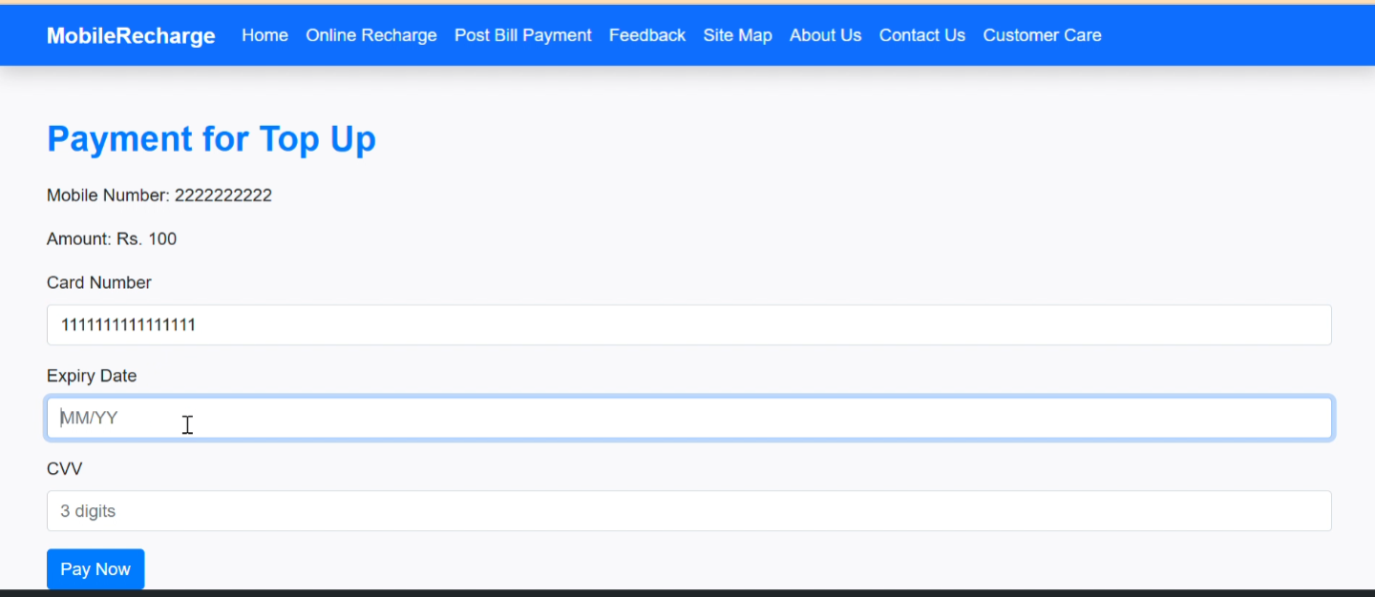

Recharge Option:

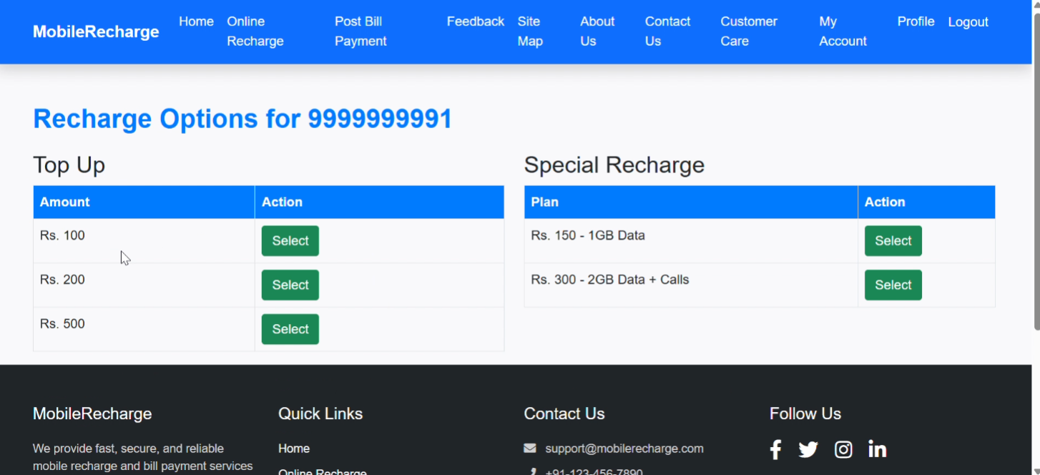

Online Recharge:

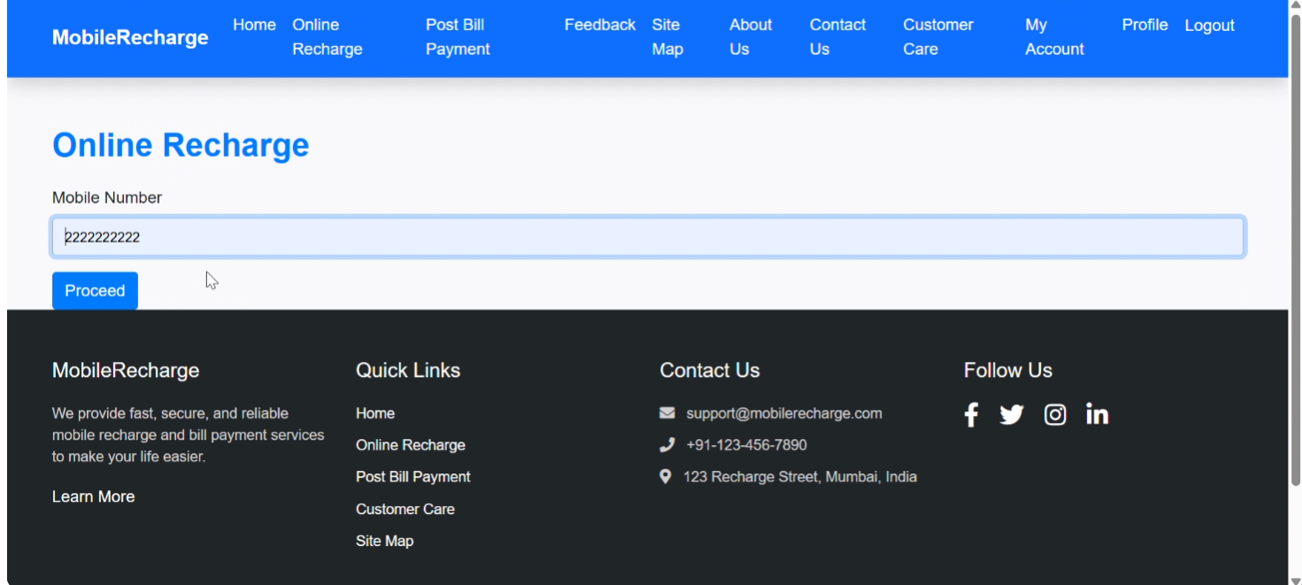

Online Recharge Validation:

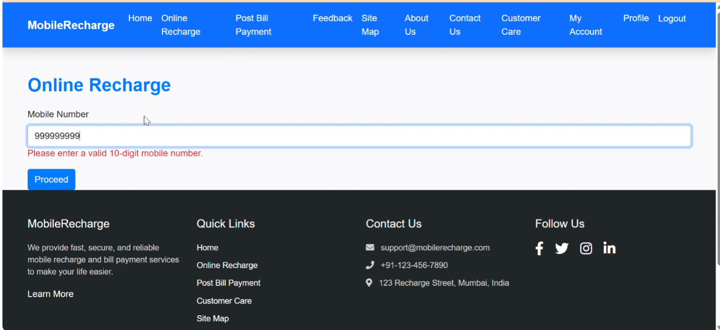

Payment for Special-Recharge:

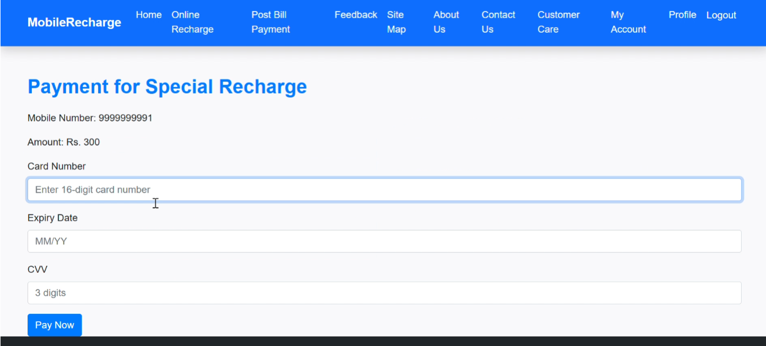

FOOTER :

